Installing R And RStudio

This document will guide you through installing R and RStudio. R is a programming language, and RStudio is an [IDE](https://en.wikipedia.org/wiki/Integrated_development_environment) that provides a graphical interface to interact with R. **Both R and RStudio need to be installed before the first lecture**. The R language itself is free, and the free edition of RStudio is sufficient for this course - **you donot need to pay for any software**. Please feel free to email me (zyousif@heath.ucsd.edu) if you have any issues with the installation.

# Windows

Installing R

1. Go to the R website: [www.r-project.org](http://www.r-project.org)
2. Under the “getting started” section, click “download R”
3. You should be on a website called “CRAN Mirrors”. Many web hosts around the world volunteer their servers to provide R for download. These are called *mirrors*. You can choose any mirror, but mirrors with close geographic proximity will likely be fastest. Scroll down and choose a mirror within the “USA” section, or any other region if you are located in a different country.
4. Click on the “Download R for Windows” link near the top of the page.
5. Click on the “install R for the first time” link.
6. Click on the large “Download R-4.4.3 for Windows” link. Save and then run the executable and follow the installation instructions

Installing RStudio

1. Go to the RStudio website: <https://posit.co/download/rstudio-desktop/>
2. Click on “DOWNLOAD RSTUDIO DESKTOP FOR WINDOWS”
3. Save and then run the executable and follow the installation instructions

Online Tutorial

1. You may reference this video tutorial for installing R and RStudio:

https://www.youtube.com/watch?v=YrEe2TLr3MI

# Mac

Installing R

1. Go to the R website: [www.r-project.org](http://www.r-project.org)
2. Under the “getting started” section, click “download R”
3. You should be on a website called “CRAN Mirrors”. Many web hosts around the world volunteer their servers to provide R for download. These are called *mirrors*. You can choose any mirror, but mirrors with close geographic proximity will likely be fastest. Scroll down and choose a mirror within the “USA” section, or any other region if you are located in a different country.
4. Click on the “Download R for MacOS” link near the top of the page.
5. Under “Latest release” click on the “[R-4.4.3-arm64.pkg](https://mirror.las.iastate.edu/CRAN/bin/macosx/big-sur-arm64/base/R-4.4.3-arm64.pkg)” link for Apple silicon (M1/M2) Macs or “[R-4.4.3-x86_64.pkg](https://mirror.las.iastate.edu/CRAN/bin/macosx/big-sur-x86_64/base/R-4.4.3-x86_64.pkg)” for older Intel Macs.
6. Save and then double click on the .pkg file and follow the installation instructions.

Installing RStudio

1. Go to the RStudio website: <https://posit.co/download/rstudio-desktop/>.

1. Click on “DOWNLOAD RSTUDIO DESKTOP FOR MAC”.
2. Save and then run the .dmg file and follow the installation instructions.

Online Tutorial

1. You may reference this video tutorial for installing R and RStudio: <https://www.youtube.com/watch?v=L5rXTo-46bI>

# Linux

Best practices will vary depending on your distribution and package manager. The R website has documentation for acquiring the most up-to-date packages for various distributions and RStudio offers builds for recent versions of Ubuntu, Fedora, and Redhat. Feel free to email me if you are having trouble installing R or RStudio on Linux.

Running Code

It is time to run a few lines of code to confirm that R and RStudio were installed successfully, and everything is running properly.

1. Run RStudio in your computer

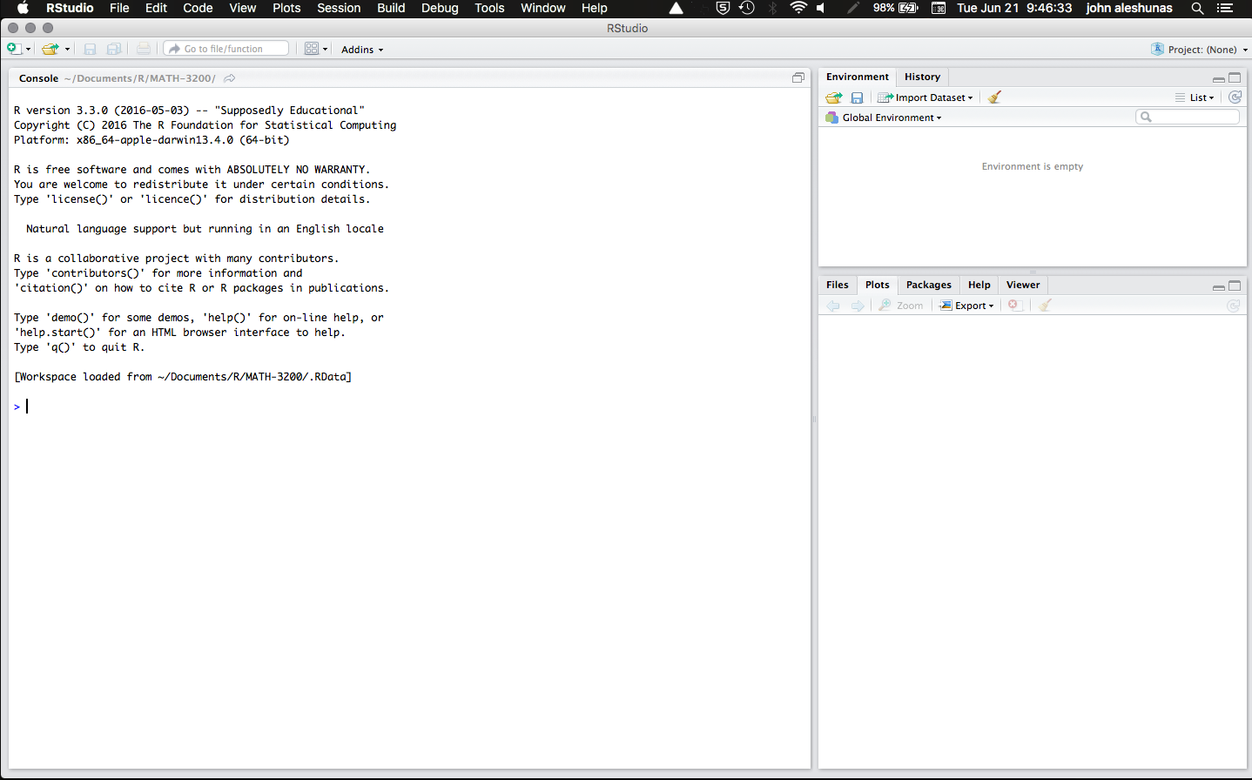

1. In the console window, run the following command:

* version

The output will look something like this, depending on your operating system and R version

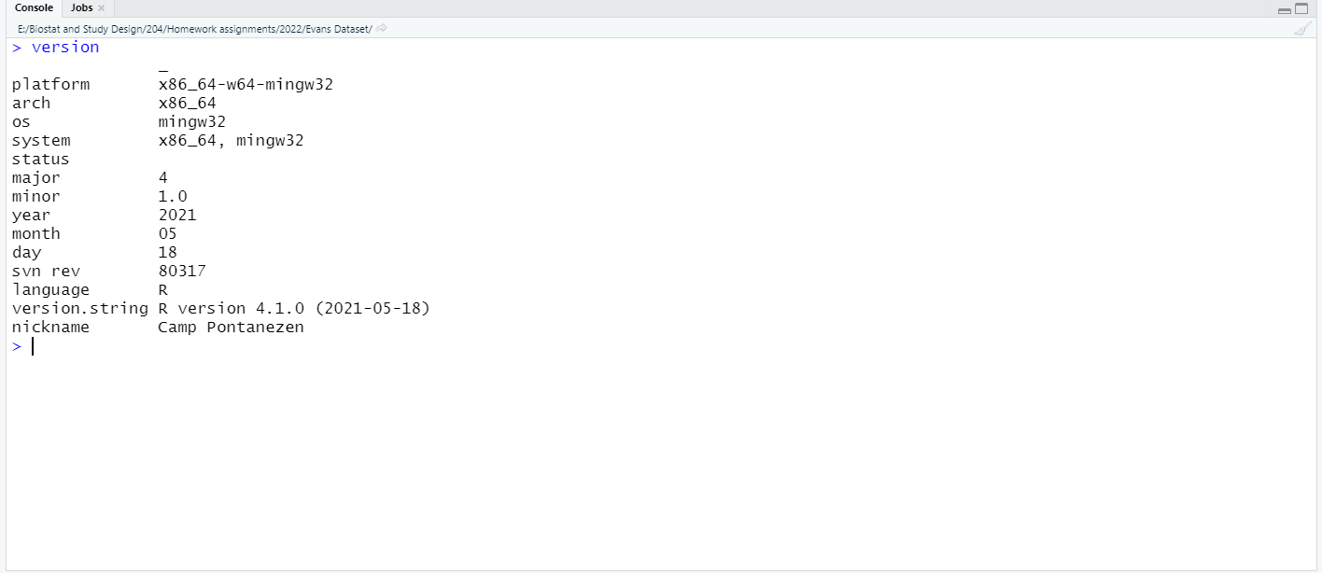

1. Next, run the following code to install R packages

* install.packages('tidyverse')
* install.packages('openxlsx')

You should get an output similar to this

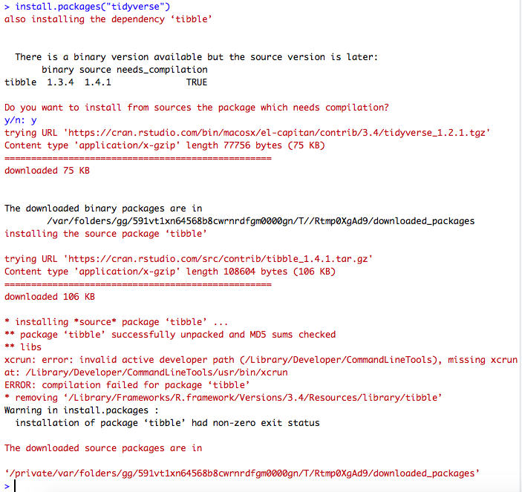

1. Load the libraries you just installed using the library command

library(openxlsx)

library(tidyverse)

